**Step 1**:

Double click on the setup file.

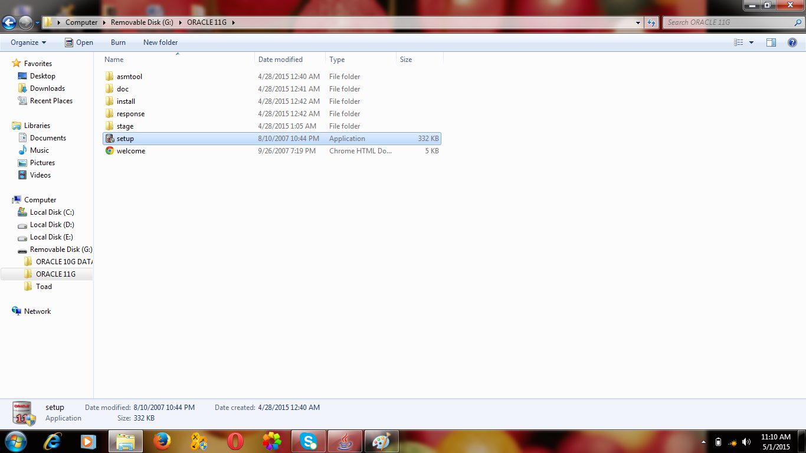

**Step 2:**

Enter the database password and confirm password as shown in image.

Two passwords must be same.and click next button.

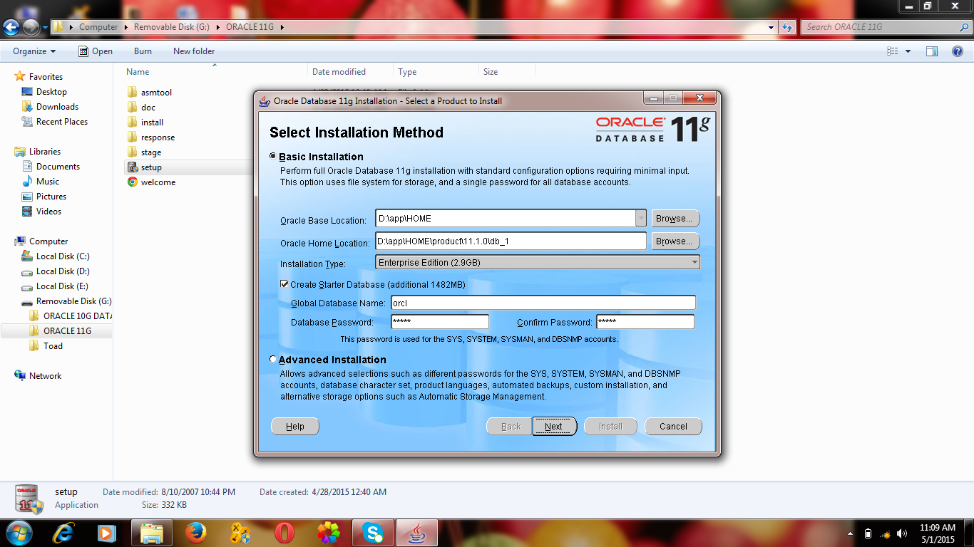

Step 3:

If this type error comes click “YES” else ignore this step.

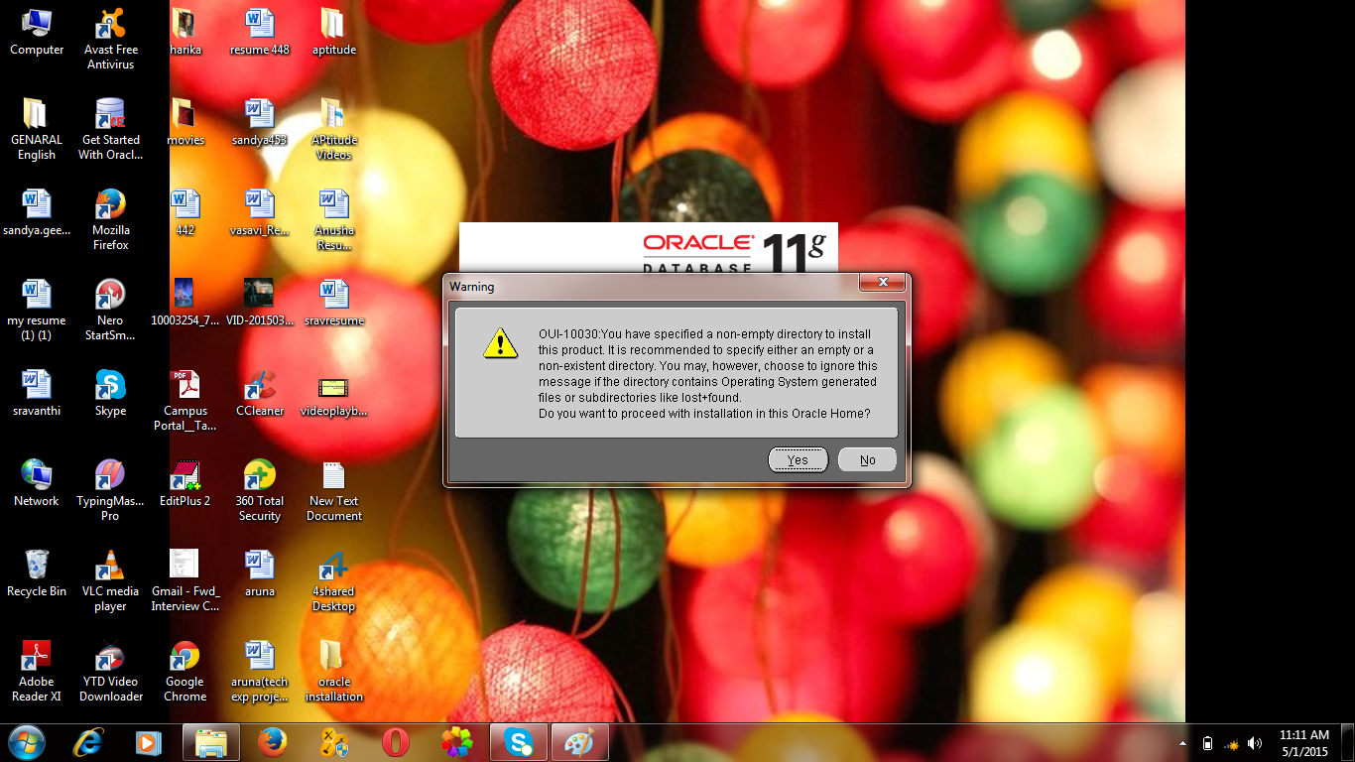

Step 4:

You have to check the check box which is selected automatically.

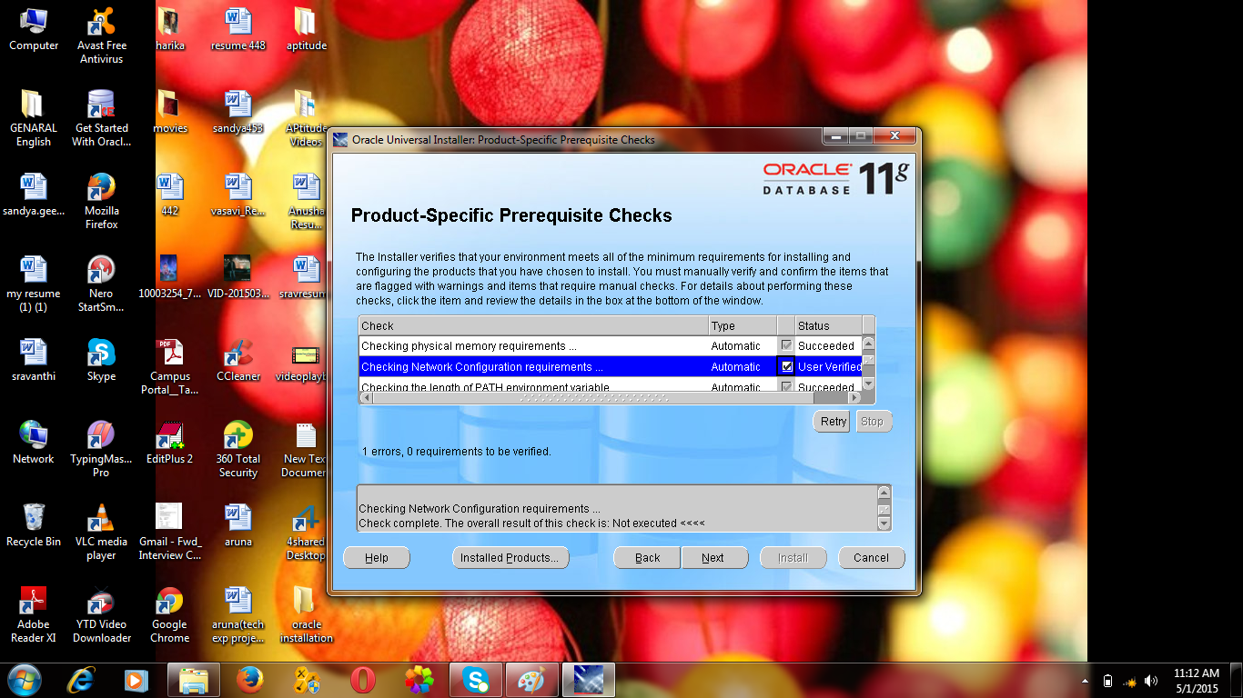

Step 5:

Click on **Allow Access** when you get this in the middle of installation.

Alfer that click Next and Install button

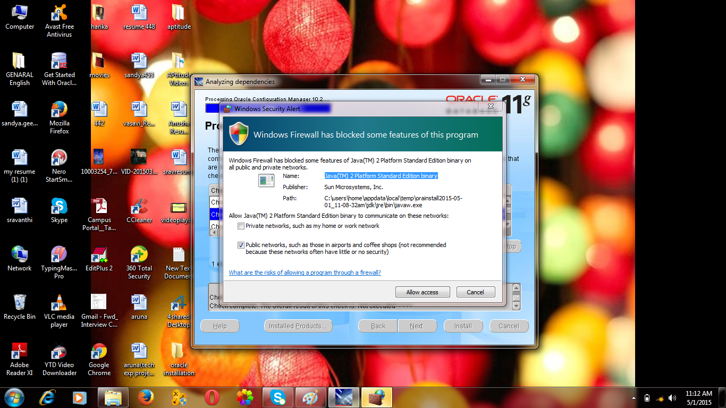

Step 6:

Click on Install button.

Now installation starts and it will take around one hour or 40 minutes.

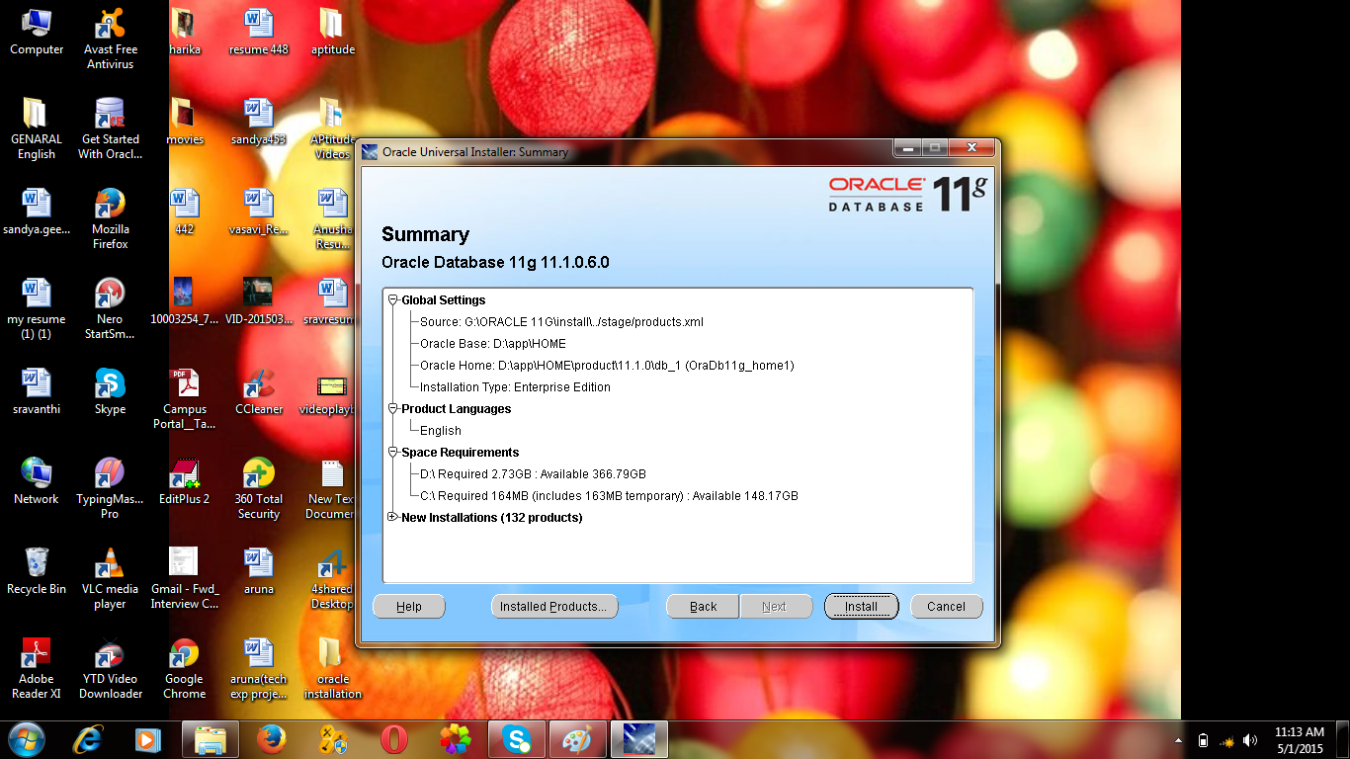

Step 7:

After complete the process the below window will come you have to select **PASSWORD MANAGEMENT.**

After that you have to remove tick mark for scott user and enter password and confirm password.

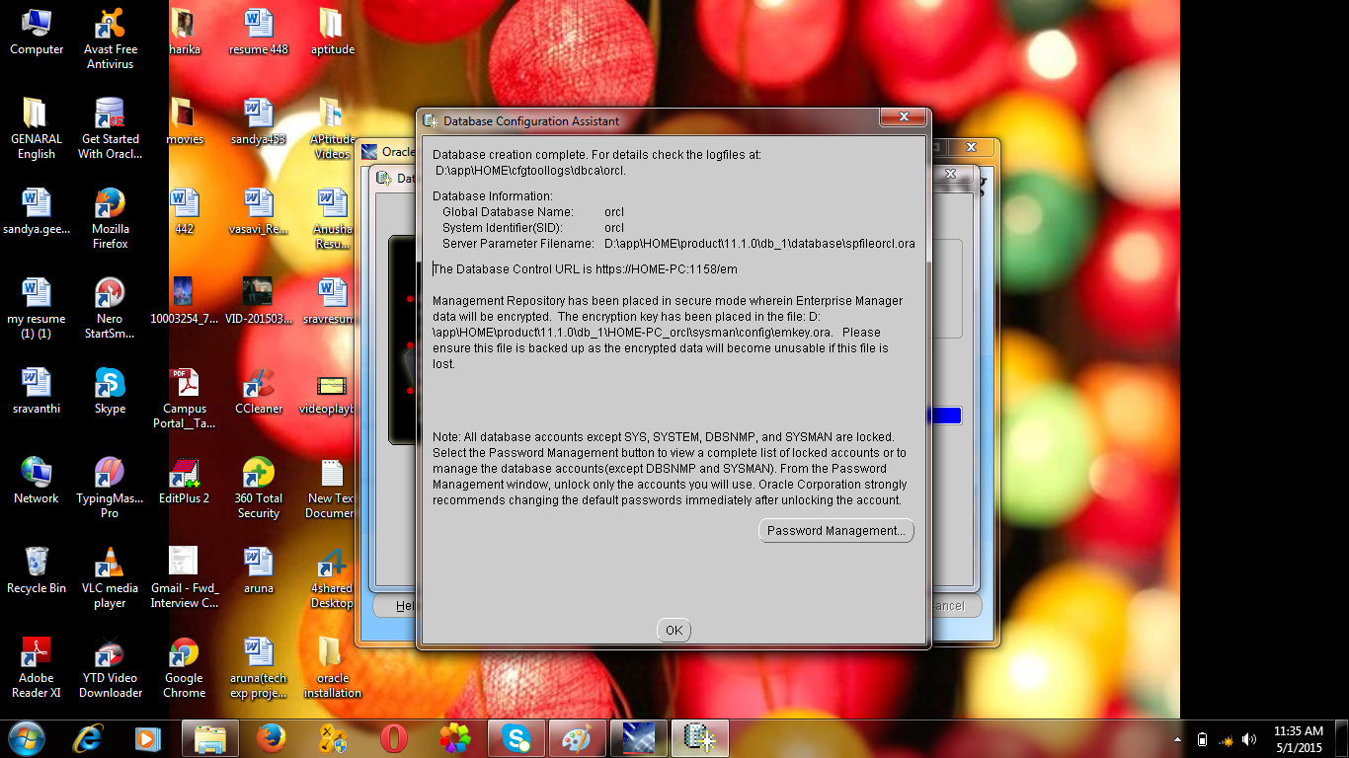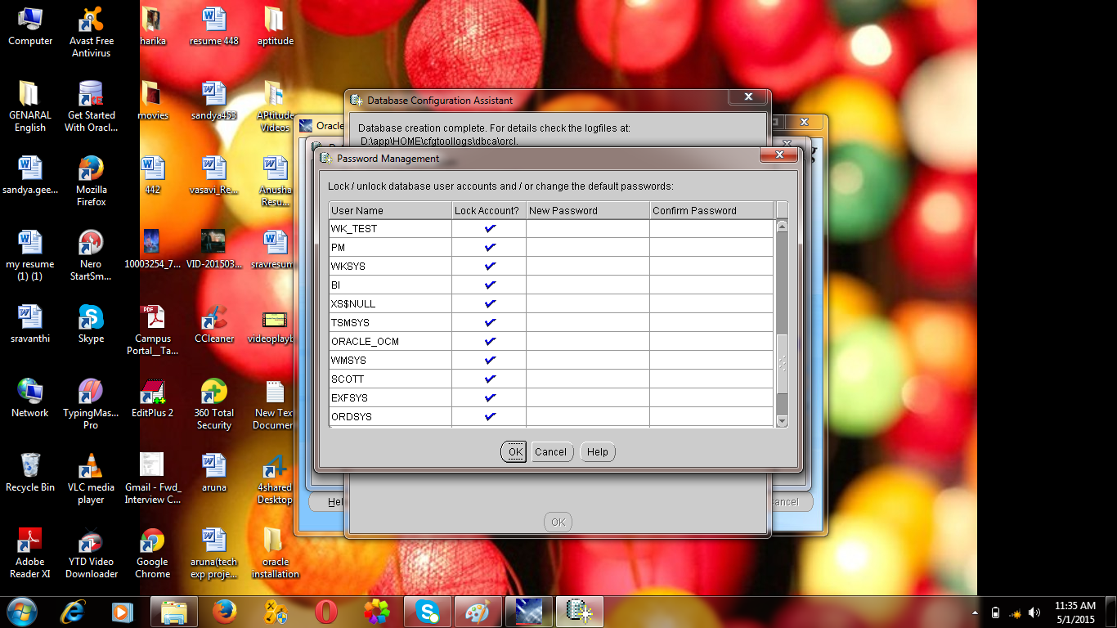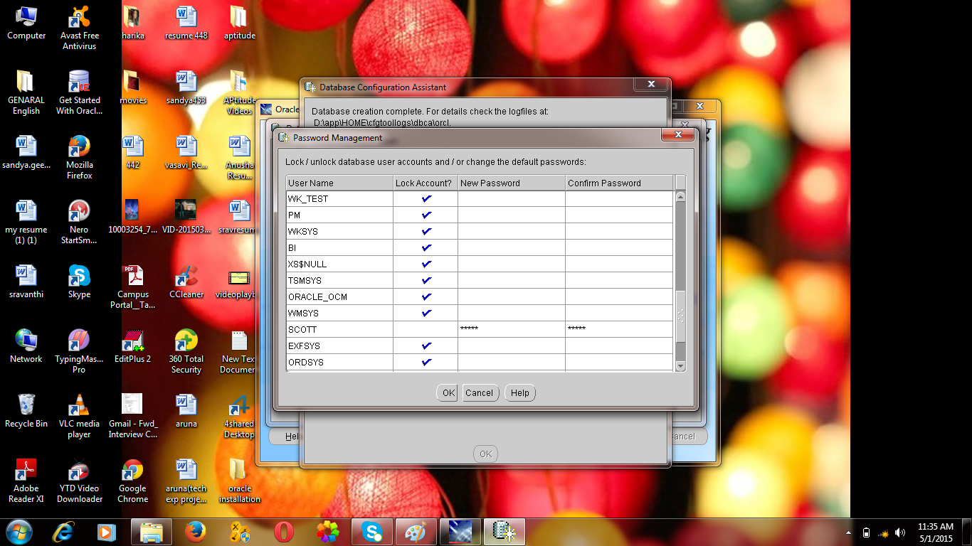

Step 8:

Default for system and sys user there is no tick mark .

The password for sys and system is which you have entered password at beginning that is

database password will be assigned for sys and system.

Then click ok and then click exit button.

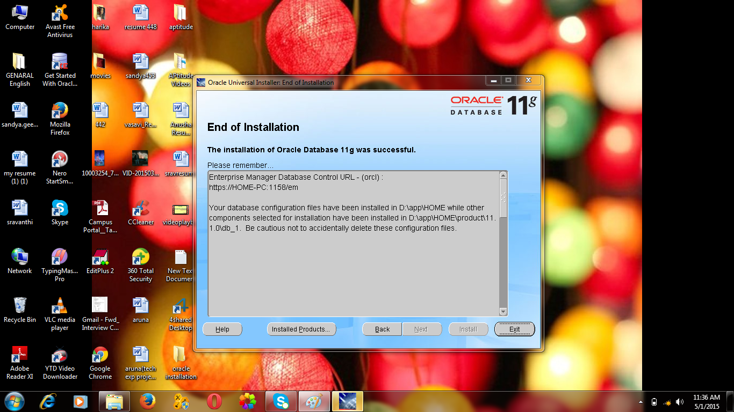

After completing the installation you will get the dialogue box click on program successfully installed.

